New Schönhof Quarter in Frankfurt:
Europe-wide architectural competition
launched for the centre of the quarter

Nassauische Heimstätte | Wohnstadt Group and
Instone Real Estate striving for high levels of architectural diversity /
Participants are given great creative freedoms

Frankfurt am Main – The development of the future Schönhof Quarter in Frankfurt’s Bockenheim district is gradually taking shape: In coordination with the city of Frankfurt, the Nassauische Heimstätte | Wohnstadt Group and listed residential developer Instone Real Estate are preparing the development of the first two building plots for the new quarter with a Europe-wide architectural competition. Around 100 firms responded to the call for tenders. Twelve were selected in the first round. Entrants have until the end of the year to submit their plans, designs and models. The decision as to who receives the contract will be made in February. The jury will then meet and evaluate which participants have best fulfilled the four main evaluation criteria – urban planning concept, fulfilment of spatial design and functional requirements, quality of design and spatial approach, economic efficiency.

Primary school, sports hall and apartments – all under one roof
The task for the competition participants is to design a plan for the future centre of the Schönhof Quarter, located on the former Siemens site. Covering around 17,000 square meters, its two buildings and the square in-between connect the residential areas in the east and west of the quarter, forming the infrastructural backbone of the future neighbourhood. The building north of the square will house retail businesses, apartments and a kindergarten. South of the square, a primary school with a sports hall and apartments will be accommodated under one roof for the very first time in Frankfurt. All apartments in this complex must comply with the city’s funding regulations.

The project partners are striving for a high level of architectural diversity and quality for the entire quarter. “There will be other architectural competitions in the course of the further development of the Schönhof Quarter,” says Dr Constantin Westphal, CEO of Nassauische Heimstätte. “However, this one is definitely the most complex, given the size of the plots and the various intended user groups. We are very excited to see the results and are looking forward to the many good concepts we know we can expect from the participants.” Ralf Werner, head of Instone’s Rhine-Main branch adds: “A large part of the infrastructure of the future Schönhof Quarter will be built around this central square. It is not just sensible from a planning point of view, but also inevitable that planning and construction should begin here.”

Goal: A lively neighbourhood for all sections of society
In total, the Schönhof Quarter will comprise a development of over 2,000 apartments on the 15 building plots of Nassauische Heimstätte and Instone Real Estate. The two companies have acquired approximately 125,000 square meters of land in the eastern section of the “Südlich der Rödelheimer Landstraße” planning area for this purpose. The aim is to have a mix of 30 percent subsidised apartments (First and Second Funding Channel “Förderweg“), privately financed rental apartments and owner-occupied apartments. The goal of the project partners is to develop a lively residential quarter for all sections of society, with affordable housing and the necessary infrastructure. An urban area will be developed in the western section of the Schönhof Quarter that will combine living and working spaces. This would also allow existing businesses to remain here. Prospective home owners can already register at www.schönhof-viertel.de/?locale=en.

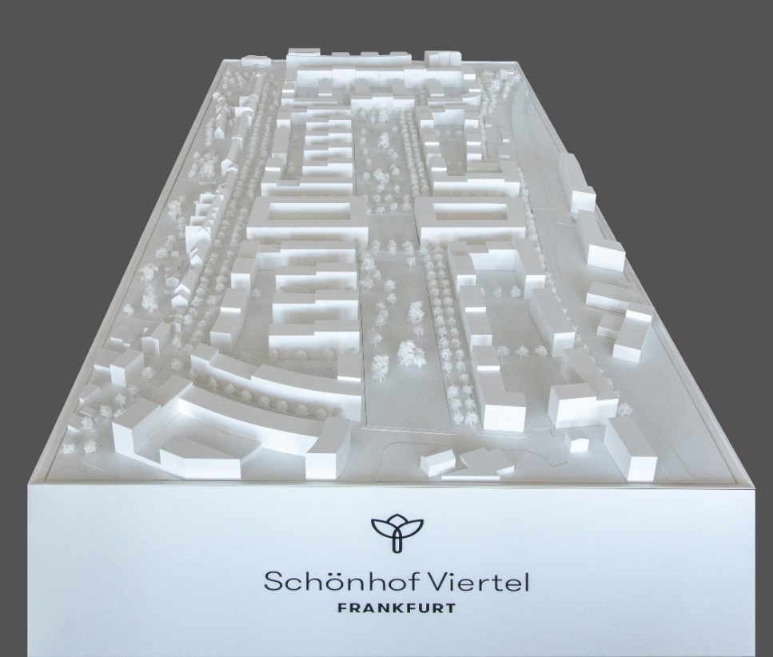

The new centre: The two O-shaped buildings in the centre are the area of interest for the architectural competition. Apartments, retail businesses and a kindergarten are planned in one building complex, in the other complex apartments and a primary school with a sports hall. Photo: Lisa Farkas

Nassauische Heimstätte/Wohnstadt Group
The Nassauische Heimstätte/Wohnstadt Group with its headquarters in Frankfurt am Main and Kassel has been providing a wide range of services in the housing, construction and development segments for 95 years and currently employs around 730 members of staff. With around 60,000 rental apartments in 140 cities and towns, it is one of the leading German housing companies. Its housing portfolio is currently managed by around 260 employees in four regional centres that are divided up into 13 service centres. The Frankfurt regional centre manages around 19,800 apartments, including 16,000 right in Frankfurt. With the ProjektStadt brand, it is pooling expertise to perform sustainable urban planning tasks. It plans to invest €1.5 billion in its portfolio and in the construction of new apartments by 2021. This will lead to the construction of 4,900 additional apartments in the next five years.

About Instone Real Estate (IRE)
Instone Real Estate is one of Germany's leading residential developers and is listed in the Prime Standard at the Frankfurt Stock Exchange. The company develops attractive multi-family and residential buildings as well as publicly subsidized housing, designs modern urban quarters and refurbishes listed buildings for residential use. Buyers are mainly owner-occupiers, private investors and institutional investors. In 27 years, Instone Real Estate has successfully developed more than one million square metres. Around 300 employees work at eight locations nationwide. As of 30 June 2018, Instone Real Estate's project portfolio comprised 44 development projects with an expected total sales volume of roughly EUR 3.6 billion and around 8,900 units.

